Nombre____________________________________ Fecha_____________ Bloque__________

Español II
Unidad 4

Parte 3: La Ropa
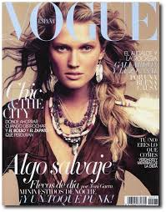
Clase, Empezamos a planear nuestro viaje a España¡ ¡Tu maestra de español fabulosa tiene una sorpresa! Vas a almorzar con el actor muy famoso de España, Antonio Banderas. Entonces, vas a cenar con el Rey Felipe VI. Necesitas la ropa de moda para estos eventos de gran importancia. ¡Vamos de compras!

Ropa 1: El Euro

Directions: Before we go shopping it is important to understand the value of the euro. Using the following website, find out the current conversion rate of the U.S. dollar to the euro. Complete the following task.

www.xe.com

1. $1 = ________________ €
2. $2,500 = _______________ €
3. A pair of shoes cost 79,99€. How much is that in U.S. dollars? $ __________________
4. Your lunch with Antonio Banderas at the café costs 35€. How much is that in dollars? $ _______________
5. Dinner with the king at La Casa Botín was expensive! It cost 95€ for the meal and an additional 12€ for your glass of Perrier. How much did the meal cost in dollars? $ _______________________
6. You took a taxi from your hotel to dinner. You gave the driver 30€. How much did the cab ride cost you in dollars? $ ____________________
7. You purchased a new umbrella to bring with you. It cost $36.00 or ____________ €
8. Total up the costs of your two meals in U.S. dollars. $__________________
9. What is that total in euro? ___________________ €

Ropa 2: Ir de Compras

Directions: Now that you have a better understanding of the euro, you need to go shopping for two outfits to wear to these important events. You will need two new outfits that are appropriate for the events and are currently in style in Spain. Use the following websites to shop for your outfits. You must have a complete look with clothing, shoes and accessories. Your lunch outfit will be more casual and your dinner outfit will be dressy. You have a budget of 500 €.
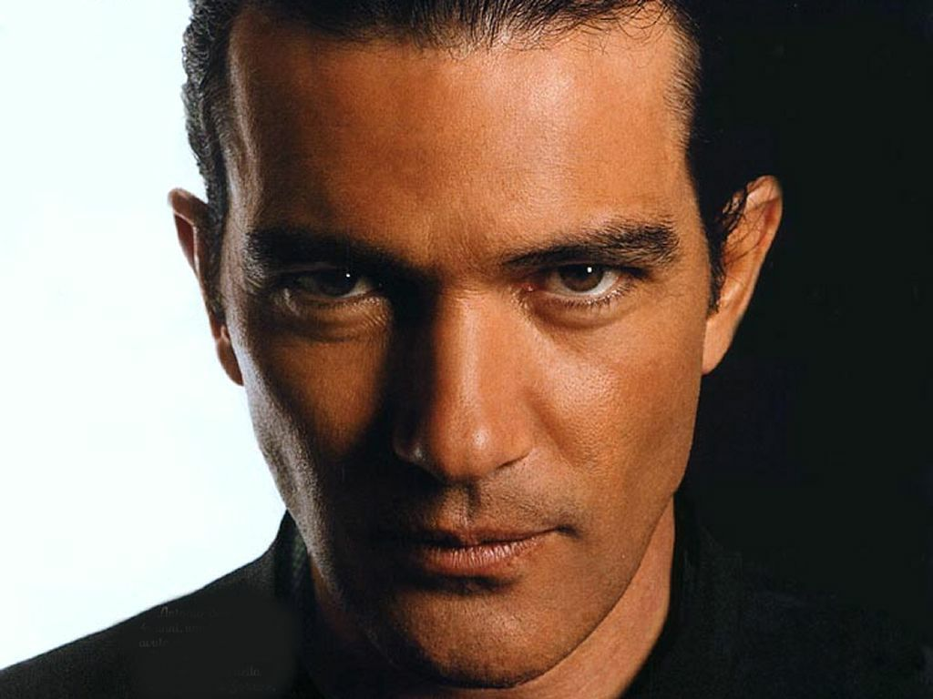
www.elcorteingles.es
www.promod.es
www.hm.com/es
www.zara.es

Lunch with Antonio Banderas

Clothing, Shoes, Accessories | Website | Color | Brand | Price $ | Price € | Picture

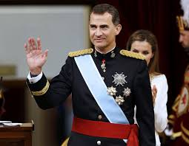

Dinner with Rey Felipe VI

Clothing, Shoes, Accessories | Website | Color | Brand | Price $ | Price € | Picture

